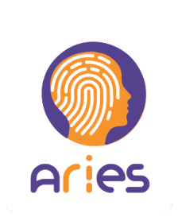
ARIES final workshop

8th February 2019

Venue: Sonae Learning Centre
Building 1A
EN;13 Km. 6,78
Lugar do Espido, Via Norte
4470-909 Maia
(Porto, Portugal)

Time |  | Topic
09:30h | 09:45h | - Opening
09:45h | 10:00h | - What is ARIES?
10:00h | 10:30h | - eCommerce and airport demonstrators’ presentation
10:30h | 10:45h | Coffee break
10:45h | 11:30h | - Hands-on, experimentation
11:30h | 12:30h | - Round table:  Findings, feedback and potential technology adoption
12:30h |  | Closing and Lunch

